
Volunteer Survey 2025

What we heard from you – a summary of responses to our 2025 volunteer survey
Thank you to everyone who shared their views in our recent volunteer survey. Please find below a summary of your responses and actions we plan to take forward.

Who you are and how you get involved
Responses came from across the UK from volunteers at all stages of their journey. The pie chart below illustrates the geographic distribution of survey respondents, while the bar graph displays the length of time respondents have volunteered for Mary’s Meals.
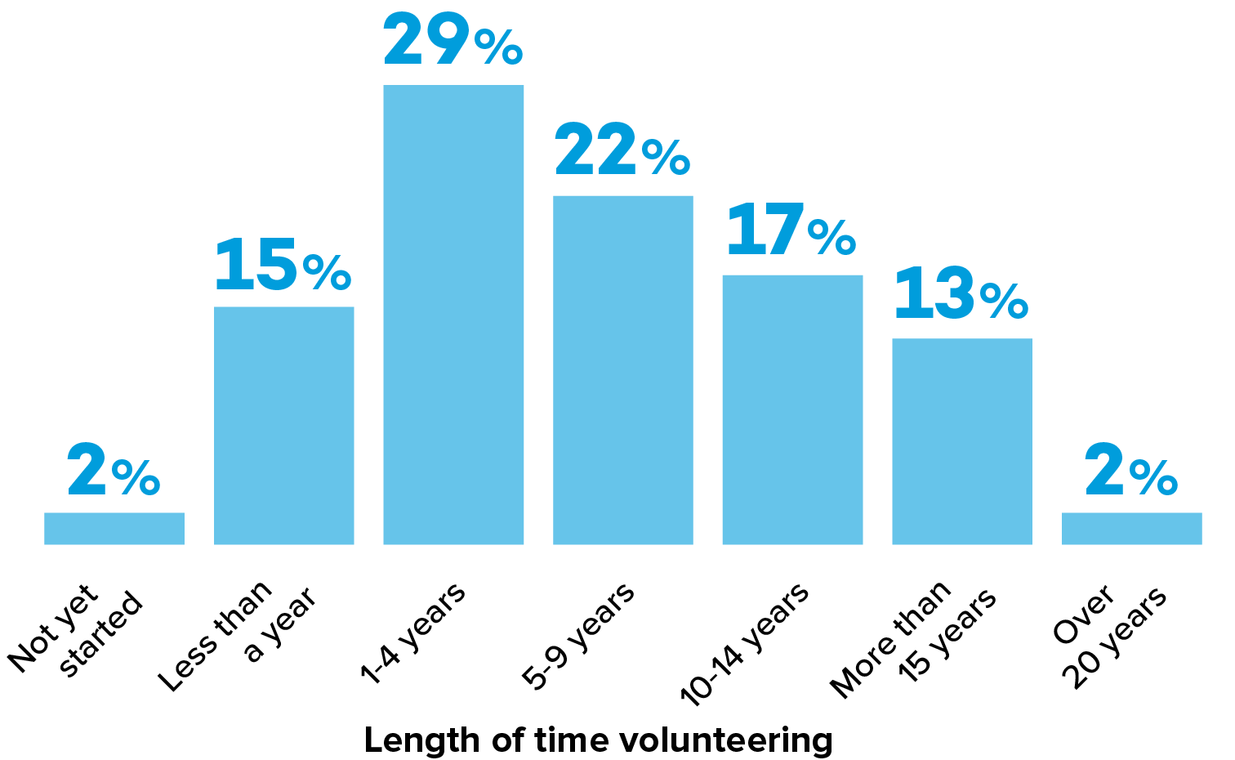
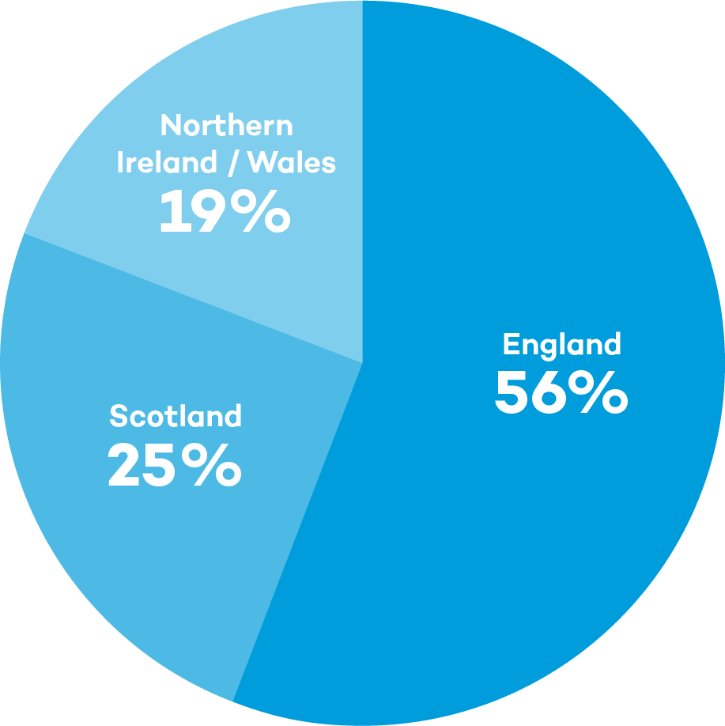

Of those who responded, 42% of volunteers said they feel confident and happy in their current role, while 24% would like to try new things or take on more responsibility. Around 16% said they aren’t sure what other volunteer opportunities are available – showing the importance of clear routes into different types of volunteering. Please get in touch with your Supporter Engagement Officer if you would like to discuss other ways to get involved!

What motivates you
Volunteers are deeply motivated by the impact of the Mary’s Meals school feeding programme. Close to half (43%) of those who responded said their main motivation is helping children directly, and 40% are inspired by our low-cost model. What people enjoy most about volunteering includes the sense of community (34%), making a direct difference (30%), and supporting a charity that relies on volunteers (12%).
Reassuringly, 78% of volunteers feel valued, and Supporter Engagement Officers were often referenced as a great source of support.

Induction, connection and support
In answer to questions about our volunteer induction process, 58% of those who responded said they found the induction helpful, particularly learning about the Mary’s Meals story and mission (47%). Around a quarter of volunteers (24%) said the feel very connected to our mission; however, connection also remains an area for us to work on with 36% of those who responded saying they feel not very, or not at all, connected. Volunteers would like more peer support, buddying, and chances to meet others locally so this is something we will continue to explore.

Communication – what works best
Clear, regular communication really matters. Of those who responded, 79% of volunteers said they prefer email. Content that people like to see includes stories about the children we support (72%), what other volunteers are doing for Mary’s Meals (48%), and opportunities to connect locally with other supporters (46%). Key themes of interest in our work include education (75%), hunger (74%), and girls’ education (58%). On using WhatsApp as a communication channel, 54% of volunteers value regional WhatsApp groups they are already in, while 66% said they would join a volunteer WhatsApp group – so this is something that we will be looking at going forward.

Skills, opportunities and looking ahead
While most volunteers reported feeling useful, some volunteers feel their professional skills are underused. Encouragingly, 58% said they would be interested in offering pro bono support or helping with future projects if clearer opportunities were available – something we’re actively exploring. Please get in touch with your Supporter Engagement Officer if you have other skills you would like to offer.
Volunteer commitment is strong: 79% are very likely to still be volunteering in 12 months’ time, with a further 11% likely to continue. The main barriers to volunteering were reported to be health, time, and other commitments.
Thank you for everything you do for Mary’s Meals. Your time, skills, and care make a real difference, and this feedback will help shape how we support and connect with our volunteers moving forward.

